Book 17 and 18 review questions: quiz Monday the 18th
these first few questions deal with how we deal with fallen friends and death itself. Homer of course uses the epic simile—it is, I feel, quite apt.

The Iliad - Book 17 - Menelaus’ Finest Hour - The fight for Patroclus’s body
- Reading time: about 55 minutes but just read lines 1-240 and then 445-543 and then 618-675 and then 705 to the end
- We want to find out Achilles’s reaction to the killing of Patroclus, but this book holds us back from seeing that as the Trojans and Menelaus and Ajax fight over the body of Patroclus.
- The importance of cremation and burial.
- Without proper cremation and burial of the ashes, the Greeks believed the dead person could not properly go down to Hades.
- Achilles’ armor
- Patroclus went to battle wearing Achilles’ armor. Hector has stripped Patroclus of that armor, so Achilles, when he reenters battle, will have no armor.
- Book 18 will show us how Achilles got new armor. It will also give us a view of ideal Greek life in Homer's time.

- What is Menelaus like as he stands over the body of Patroclus? Why does Homer use
this simile?
- What simile does Homer use to describe the dying Euphorbus? What is the tone of his description?
- How is Menelaus like a mountain lion? What are the other Trojans like as they watch
him despoil Euphorbus? Relates to q.2.
- The question deals with wasted energy. What does Apollo tell Hector about the horses? What should Hector be doing? How often do we waste our resources (time and energy) on the wrong things? What is the result?
- What argument does Menelaus have with himself? What does he finally decide to do,
and why?
- How do the Achaeans now feel about war? Line 850

The Iliad - Book 18 - The shield of Achilles: this book is very important. Achilles learns of Patroclus’ death and will enter the battle.

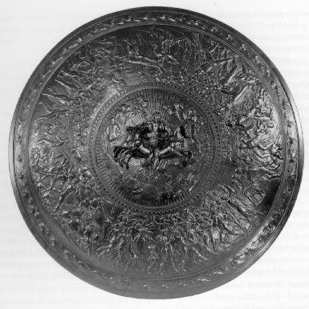
- Achilles learns of Patroclus’s death. 1-109.
- The death of Patroclus is reported in brief words to Achilles. In two and a half lines of simple diction, Antilochus tells Achilles what has happened: “Patroclus has fallen. They're fighting over his corpse. He's stripped, naked—Hector with the flashing helmet, Hector has your arms.” (21-23)
- Watch as Homer has Achilles say not a word in his grief except an inarticulate cry until he finally speaks on line 92. Achilles is a character of the greatest passions, yet the depiction of his initial reaction is wordless. It is a fascinating poetic touch that Homer lists 14 lines of names of sea nymphs at this point. Their names are probably chosen for the mellifluousness of sound rather than for any meaning. It is as if the aural meaning takes precedence over the intellectual at this point—sound over sense.
- Mueller says, "The death of Achilles begins with the news of Patroclus' death" (58). By this he means that dying characters may reflect briefly upon the meaning of their life. Achilles (perhaps most notably among all literary characters) is allowed the most extensive reflection of all. Achilles does not die in The Iliad. His death comes afterwards. Hence, his death is reflected in the death of Patroclus.
- Thetis speaks with Achilles. 109-172.
- Thetis comes up from the sea to console her son over his loss.
- As always, Thetis reminds Achilles of his mortality and impending doom.
- Achilles both regrets his decision to remain in camp nursing his anger and simultaneously wants to go to seek vengeance on Hector.
  - Achilles turns his anger from Agamemnon to Hector (131).
- Thetis goes to get a new set of immortal armor made for him by Hephaestus.
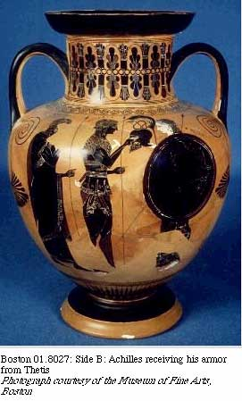
- The appearance of Achilles in battle 233-
- Iris urges Achilles to get Patroclus’ corpse, but, without armor, Achilles can't enter battle. Iris tells him just to stand in battle and his mere presence will intimidate the Trojans.
- His appearance is remarkable. His body shines and is magnified. Athena makes blazing light emanate from his head. With this visual metaphor, Achilles is present and changes all reality around him. He works miracles by his presence, to borrow vocabulary from the much different culture of Christianity.
- Hector once again rejects advice. 280-
- Polydamas advises Hector to retreat back to Troy: make Achilles fight around the walls of Troy. Hector rejects this advice (330), wanting to go out to meet Achilles and fight him. Remember that Hector rejected Polydamas's advice back in Book 12 and was wrong.
- The narrator comments on Hector's folly: "The Trojans raired their assent, lost in folly. Athena had swept away their senses” (361-).
- Achilles tends Patroclus' body
- The shield of Achilles. 430-end.
- Here, in this pause before the final killings of the epic, Homer inserts a magnificent picture of the fullness of life and art.
- The god Hephaestus creates a fighting shield of such detail and beauty, we forget in the description that we are hearing about a work of art and not actual life.
- Here we see every phase of life beyond the battlefield, from war to hate, from birth to death.
- Discuss the symbolic meaning of the shield of Achilles in the context of this book. This is an excellent essay question. We’ll hold off on it for now
Okay, this chapter is deep. I’m giving you as few questions as possible. They are due Monday morning. Your 13-18 quiz is also Monday. The book 18 questions alone are worth 30 points

How does Achilles respond to the formal news of Patroclus’ death? Why does he do this?
- What does Thetis tell the other nymphs? How is her speech relevant to the poem as a whole?

*** What does Achilles answer when Thetis asks why he is not happy with the outcome of the battle? After all, he desired to see Agamemnon punished. Does Achilles answer mark a fundamental change in him? What has he realized?
- What does Achilles say about courage and wisdom? What does he say about his own wrath?
- Why does Homer have Achilles mention the Trojan women? Another good question. When do we lose our humanity? Is it preventable? (you do not have to answer the last two parts—merely consider them)

Here’s an easy one. What does Hera do to aid the Achaeans? Why does she do this?

What is Haephstus’ relation to Thetis? Why does Homer provide this background information? A real quid pro quo

